# **Power BI Project Documentation**

**Project Title:** MAVENTECH SALES DASHBOARD

### **Project Overview**

The Mavin Tech Sales Performance Dashboard is a Power BI solution designed to provide insights into the performance of sales agents, regional sales distribution, product-wise sales trends, and detailed account-level sales data.  
The dashboard enables managers to track KPIs, identify high-performing agents, evaluate win/loss patterns, and analyze sales by geography and sector.

**Objective**

- **Track key sales KPIs** such as total revenue, win rate, number of wins, and average deal closure time.

- **Evaluate sales agent performance** to identify top performers and areas for improvement.

- **Analyze product-wise and region-wise sales trends** to guide strategic decision-making.

- **Compare win vs loss patterns** to improve deal conversion rates.

- **Enable quick analysis** for detailed account-level insights.

Data set Overview

The dataset spans from October 2016 to December 2017 and is exported from MavenTech’s CRM system.MavenTech , a company that specializes in selling computer hardware to large businesses.They’ve been using a new CRM system to track their sales opportunities. The following tables were used:

* **Sales Pipeline Table (Fact Table)**Contains 8,800 rows and 8 fields, including opportunity ID, sales agent, product, account, deal stage, engagement dates, closure dates, and revenue from deals.
* **Accounts Table (Dimension Table)**Contains 85 rows and 7 fields, detailing company information, such as industry sector, revenue, number of employees, and parent company relationships.
* **Product Table (Dimension Table)**Contains 7 rows and 3 fields, listing products, product series, and suggested retail prices.
* **Sales Teams Table (Dimension Table)**Contains 35 rows and 3 fields, detailing information on sales agents, managers, and regional offices.

Data Model

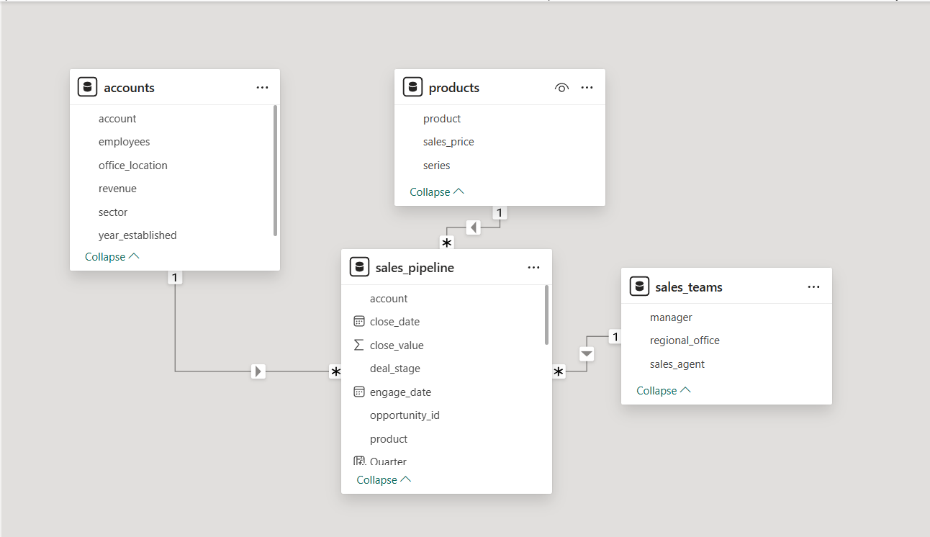

### **Dashboard Pages**

#### **Page 1: Agent Performance**

* **Purpose:** Monitor overall and individual sales agent performance.
* **Key Visuals & Metrics:**
  + **KPIs:**
    - Total Sales (10M)
    - Average Days to Close (47.99 days)
    - Wins (4,238)
    - Win Rate % (63.15%)
    - Average Sale Value (2.36K)
    - Opportunities Engaged (1,589)
  + **Donut Chart:** Product-wise Revenue Share
  + **Clustered Column Chart:** Win vs Loss Analysis by Quarter
  + **Horizontal Bar Chart:** Performance Rank by Sales Agent
  + **Horizontal Bar Chart:** Total Sales by Sales Agent
* **Filters/Slicers:** Manager, Sector, Quarter, Product

#### **Page 2: Sales Team Region & Product**

* **Purpose:** Visualize sales distribution across regions, industries, and products.
* **Key Visuals & Metrics:**
  + **Map:** Total Sales by Country
  + **Horizontal Bar Chart:** Total Sales by Industry
  + **Horizontal Bar Chart:** Total Sales by Product
  + **Horizontal Bar Chart:** Win Rate % by Product
  + **Table:** Total Sales & Number of Sales by Account (with wins/losses)
* **Filters/Slicers:** Manager

#### **Page 3: Sales Report**

* **Purpose:** Provide a detailed breakdown of sales transactions for deeper analysis.
* **Key Visuals & Metrics:**
  + **Slicer:** Select Agent
  + **Table:** Columns include:
    - Sales Agent
    - Product
    - Account
    - Total Deals
    - Wins
    - Average Days to Close
    - Office Location
    - Win Rate %
    - Total Sales
  + **Summary Row:** Shows overall totals for all metrics

**Measures and Calculations**

* **Average Days to Close** – Average number of days taken to close a deal.
* **Average Sale Value** – Average monetary value of closed deals.
* **Close Value** – Total value of all closed deals.
* **Dashboard 2** – Second view or page of the sales dashboard.
* **Lost Deals** – Number of deals that were lost.
* **Opportunity Engaged** – Number of potential deals actively worked on.
* **Performance Rank** – Ranking of sales agents based on performance.
* **Performance Score** – Calculated score reflecting sales performance.
* **Sales % of Won Total** – Percentage share of total won sales
* **Sales report header** – Title or header section for the sales report.
* **Total Deals** – Total number of deals
* **Total Sales** – Total value of won sales.
* **Total sales count wins + losts** – Total number of deals including both wins and losses.
* • **Welcome Dashboard** – Introductory page or landing view of the sales dashboard.
* • **Win Rate %** – Percentage of deals won out of total deals.
* • **Wins** – Number of deals successfully closed.

Key performance indicators (KPIs)

• **Total Sales:** The total revenue generated. The dashboard shows this as **10M**.

• **Average Days to Close:** The average number of days it takes to close a sales deal. The value shown is **47.99**.

• **Wins:** The total number of successful sales deals. The value is **4238**.

• **Win Rate:** The percentage of deals won out of the total deals. The value is **63.15%**.

• **Average Sales Value:** The average value of a single sales deal. The value is **2.36K**.

• **Opportunity Engaged:** The number of sales opportunities that have been worked on. The value is **1589**.

Key Insight

Page 1

**Sales by Product:**

* The dashboard shows a pie chart for "Product wise Revenue."
* **GTX Pro Plus** is the dominant product, accounting for 50.0M in revenue, which is 50.05% of the total.
* **GTX Pro 4M** is the next largest with 35.0M (35.05%).
* **GTX Plus Basic** and **MS Advanced** represent smaller portions.

**Performance by Sales Agent:**

* There's a bar chart showing performance by sales agent.
* **Darcil schlecht** appears to be the top performer with a score of 50.

**Total Sales by Sales Agent:**

* Another bar chart shows total sales by agent.
* **Darcil Schlecht** has the highest total sales, at $1.7M.

**Win vs. Loss Analysis:**

* A clustered column chart shows "Win vs. Loss Analysis" over time, likely by quarter.
* The chart compares the number of wins and losses. In the most recent period (likely Q3 2023), there were significantly more wins (1227) than losses (766), indicating a positive trend.

Page 2

**Total Sales by Country:**

* A world map visualizes sales performance.
* **America** appear to be the primary sales regions,

**Total Sales by Industry:**

* A horizontal bar chart displays sales volume across different industries.
* **Retail** is the highest-performing industry with $1.87M in sales.
* **Technology** and **Medical** are the next largest industries.
* **Software**, **Finance**, and **Marketing** also contribute significantly.

**Total Sales by Product:**

* A bar chart breaks down sales by product.
* **GTX Pro** has the highest sales at $3.5M.
* **GTX Plus P** is second with $2.6M.
* **MG Advanced** and **GTX Pro** are also strong sellers.

**Win Rate by Product:**

* Another bar chart shows the win rate for each product.
* **MG Special** has the highest win rate at 64.30%. This is interesting given its zero sales, and might suggest it's a niche product that the team is very effective at selling when an opportunity arises.
* **GTX Pro** and **GTX Basic** have win rates in the 63-64% range.
* **GTX 500** has the lowest win rate at 60.00%.

**Total Sales & Number of Sales by Account:**

* A table provides a detailed breakdown of sales by individual accounts.

Page 3

It provides a detailed, row-level view of sales transactions.

### Strategic Recommendations:

**1. Capitalize on Strengths:**

* **Products:** Focus on selling the top-performing GTX Pro and GTX Plus P.
* **Industries:** Prioritize leads in the high-revenue Retail and Technology sectors.

**2. Address Weaknesses:**

* **GTX 500:** Analyze and improve the low win rate of the GTX 500 product.
* **Geographical Expansion:** Explore sales opportunities in regions outside of North America and

**3. Optimize Sales Process:**

* **Agent Performance:** Coach underperforming agents using best practices from top sellers
* **Efficiency:** Work on reducing the average Days to Close by streamlining the sales process.
* **Account Management:** Nurture high-value accounts and analyze reasons for losses to improve the team's overall win-to-loss ratio.

**Conclusion & Learning**

This project helped me learn how to clean, model, and visualize large datasets in Power BI. I gained skills in dashboard design, storytelling through data, and extracting business insights. Presenting this data in a simple and effective way helped me build confidence for real-world business analysis roles.